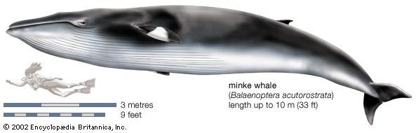MARINE FORENSICS

INVESTIGATION ASSESSMENT

Name: ____________________________________

In 1994 the International Whaling Commission prohibited commercial whaling in the Southern Ocean Sanctuary. The *Environment Protection and Biodiversity Conservation Act 1999* strengthens Australia’s policy on conservation of all cetaceans and has declared Australian waters the “Australian Whale Sanctuary”

Two Sanctuaries are currently designated by the International Whaling Commission, both of which prohibit commercial whaling.  The first of these, the Indian Ocean Sanctuary, was established in 1979 and covers the whole of the Indian Ocean south to 55°S.

The second was adopted in 1994 and covers the waters of the Southern Ocean around Antarctica.

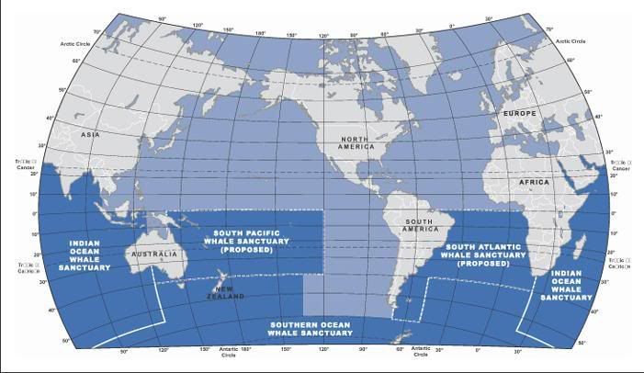

Commercial fishing boats are often found and captured in Australian Antarctic waters and their catch confiscated. Forensic Scientists carry out testing on the samples of the catch to identify the species of animal. The skippers of these fishing boats maintain that their catch is only made up of tuna.

Your task is to carry out a **gel electrophoresis** on three samples taken from the fishing boat. You have also been provided with samples of Minke Whale and Tuna for comparison.

You will then complete a **validation test** to evaluate your understanding of the investigation and the process involved.

The table below shows the wells of your gel and the samples to be loaded into each well.

|  |  |  |  |  |  |  |
| --- | --- | --- | --- | --- | --- | --- |
| Water | Minke Whale | Tuna | Sample 1 | Sample 2 | Sample 3 | Size Marker |
|  |  |  |  |  |  |  |

When you have run the gel, the banding pattern of the samples should allow you to identify the species of animal from which they were taken.

You must **complete the diagram above of the gel** when it is finished for use in making your decision.

You may bring this with you to your validation test.